 | 10.1.8 Editors - Compositor Editor - Header - Add Menu - Color
Table of content
Detailed Table of Content 1
Add menu - Color - Adjust 5
Brightness/Contrast 5
Color Balance 6
Color Correction 8
Exposure 10
Gamma 11
Hue Correct 11
Hue/Saturation/Value 12
RGB Curves 14
Tonemap 16

Detailed Table of Content

Detailed table of content
Detailed Table of Content 1
Add menu - Color - Adjust 5
Brightness/Contrast 5
Inputs 5
Image 5
Brightness 5
Contrast 5
Outputs 5
Color 5
Color Balance 6
Inputs 6
Factor 6
Image 6
Properties 6
Type 6
Lift/Gamma/Gain 6
Lift 6
Gamma 6
Gain 6
Color wheel 6
Offset/Power/Slope (ASC-CDL) 6
Offset 6
Basis 6
Power 7
Slope 7
Color wheel 7
White Point 7
Input 7
Temperature 7
Tint 7
Picker 7
Output 7
Temperature 7
Tint 7
Picker 7
Outputs 7
Image 7
Advanced 8
The Offset/Power/Slope Formula 8
Color Correction 8
Input 8
Image 8
Mask 8
Properties 8
Master panel 8
Saturation 8
Contrast 8
Gamma 8
Gain 8
Offset 8
Highlights panel 9
Saturation 9
Contrast 9
Gamma 9
Gain 9
Offset 9
Midtones panel 9
Saturation 9
Contrast 9
Gamma 9
Gain 9
Offset 9
Midtones panel 9
Saturation 9
Contrast 9
Gamma 9
Gain 10
Offset 10
Shadows panel 10
Saturation 10
Contrast 10
Gamma 10
Gain 10
Offset 10
Tonal range panel 10
Mid tones Start, Mid tones End 10
Channels 10
Red, Green, Blue 10
Outputs 10
Color 10
Exposure 10
Inputs 11
Image 11
Exposure 11
Outputs 11
Image 11
Gamma 11
Inputs 11
Image 11
Gamma 11
Outputs 11
Image 11
Hue Correct 11
Inputs 11
Image 11
Factor 11
Properties 12
Level 12
Tools menu 12
Reset View 12
Reset Curve 12
Auto Handle 12
Vector Handle 12
Auto Clamped 12
X / Y 12
Delete Points 12
Output 12
Image 12
Hue/Saturation/Value 12
Inputs / Properties 12
Image 12
Hue 13
Saturation 13
Value 13
Factor 13
Image 13
Outputs 13
Image 13
Hue/Saturation Tips 13
RGB Curves 14
Inputs 14
Image 14
Factor 14
Black Level 14
White level 14
Properties 14
Tone 14
Curve Field 14
Channel buttons 14
Navigation elements 14
Zoom in and out 14
Clipping 14
Tools 14
Reset View 15
Extend horizontal 15
Extend extrapolated 15
Reset Curve 15
Curve edit field 15
Selecting Points 15
Adding Points 15
Curve point settings 15
Vector Handle 15
Auto Handle 15
Auto Clamped Handle 15
Outputs 15
Color 15
Tonemap 16
Inputs 16
Image 16
Properties 16
Type 16
Rh Simple 16
Key 16
Balance 16
Gamma 16
R/D Photo receptor 16
Intensity 16
Contrast 16
Adaptation 16
Color Correction 16
Outputs 16
Image 16

Add menu - Color - Adjust
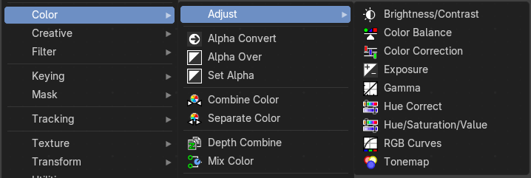
Here you find color related nodes.

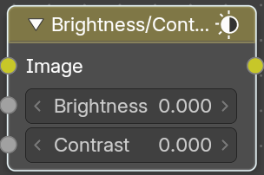
Brightness/Contrast
Adjust the brightness and contrast.

Inputs

Image
The image input

Brightness
An additive-type factor by which to increase the overall brightness of the image. Use a negative number to darken an image.

Contrast
A scaling type factor by which to make brighter pixels brighter, but keeping the darker pixels dark. Higher values make details stand out. Use a negative number to decrease the overall contrast in the image.

Outputs

Color
Standard output.
Note: It is possible that this node will put out a value set that has values beyond the normal range, i.e. values greater than one and less than zero. If you will be using the output to mix with other images in the normal range, you should clamp the values using the Map Value node (with the Min and Max enabled), or put through a Color Ramp node (with all normal defaults).

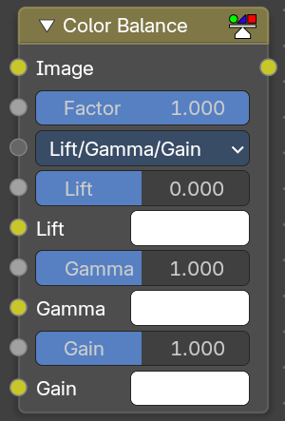
Color Balance
The Color Balance node can adjust the color and values of an image.

Inputs

Factor
Controls the amount of influence the node exerts on the output image.

Image
Standard image input.

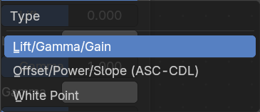
Properties

Type
You can choose between different formulas.

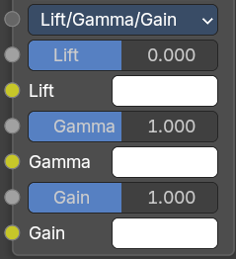
Lift/Gamma/Gain

Lift
Increases the value of dark colors.

Gamma
Will adjust mid tones.

Gain
Adjusts highlights.

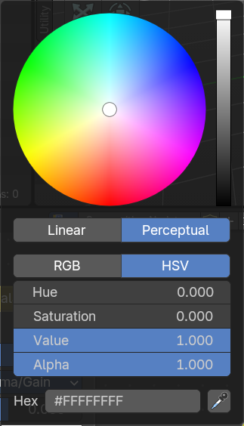
Color wheel
When you click at one of the colors then you will call a color wheel where you can adjust the colors.

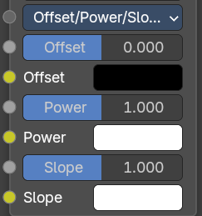
Offset/Power/Slope (ASC-CDL)

Offset
Summand. (Adjusts the overall brightness.)

Basis
Additional offset, allows to specify a negative Offset value.

Power
Over-all exponent. (Adjusts the mid tones.

Slope
Multiplier. (Adjusts the highlights.)

Color wheel
When you click at one of the colors then you will call a color wheel where you can adjust the colors.

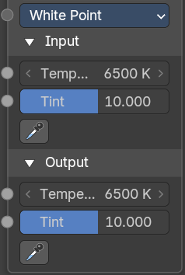
White Point
Chromatic adaption from a different white point.

Input

Temperature
Color temperature of the inputs white point.

Tint
Color tint of the inputs white point.

Picker
Pick an input whitepoint. The color that gets mapped to white.

Output

Temperature
Color temperature of the outputs white point.

Tint
Color tint of the outputs white point.

Picker
Pick an output whitepoint. The color which gets white gets mapped to.

Outputs

Image
The output image.

Advanced

The Offset/Power/Slope Formula
out = (i × s + o)p
where:
out: The color graded pixel code value.
i: The input pixel code value (0 to 1) (black to white).
s: Slope (any number 0 or greater, nominal value is 1.0).
o: Offset (any number, the nominal value is 0).
p: Power (any number greater than 0, nominal value is 1.0).

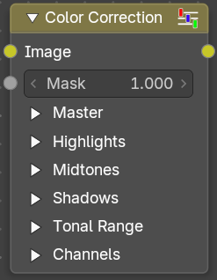
Color Correction
With the Color Correction node you can adjust the color of an image. Separated in several tonal ranges (highlights, mid tones and shadows) and only affect the necessary RGB channels.

Input

Image
Image Input.

Mask
Input a mask to cover parts of the image so that they are affected.

Properties

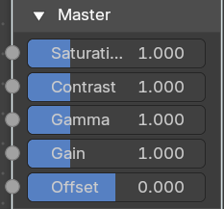
Master panel

Saturation
Adjusts the image’s saturation.

Contrast
Adjust image contrast.

Gamma
Exponential gamma correction, affecting the whole image. (Works like Power in the Color Balance node.)

Gain
Multiplier, stronger influence on the whole image. (Works like Slope in the Color Balance node.)

Offset
Controls the offset of the entire image.

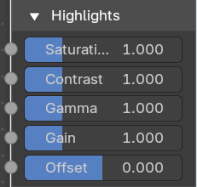
Highlights panel

Saturation
Adjusts the saturation of the highlights.

Contrast
Adjust image contrast of the highlights.

Gamma
Exponential gamma correction, affecting the highlights of the image. (Works like Power in the Color Balance node.)

Gain
Multiplier, stronger influence on the highlights. (Works like Slope in the Color Balance node.)

Offset
Controls the offset of the of the highlights.

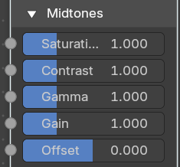
Midtones panel

Saturation
Adjusts the saturation of the midtones.

Contrast
Adjust image contrast of the midtones.

Gamma
Exponential gamma correction, affecting the midtones of the image. (Works like Power in the Color Balance node.)

Gain
Multiplier, stronger influence on the midtones. (Works like Slope in the Color Balance node.)

Offset
Controls the offset of the of the midtones.

Midtones panel

Saturation
Adjusts the saturation of the midtones.

Contrast
Adjust image contrast of the midtones.

Gamma
Exponential gamma correction, affecting the midtones of the image. (Works like Power in the Color Balance node.)

Gain
Multiplier, stronger influence on the midtones. (Works like Slope in the Color Balance node.)

Offset
Controls the offset of the of the midtones.

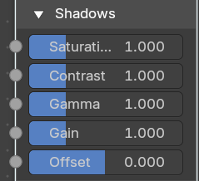
Shadows panel

Saturation
Adjusts the saturation of the shadows.

Contrast
Adjust image contrast of the shadows.

Gamma
Exponential gamma correction, affecting the shadows of the image. (Works like Power in the Color Balance node.)

Gain
Multiplier, stronger influence on the shadows. (Works like Slope in the Color Balance node.)

Offset
Controls the offset of the of the shadows.

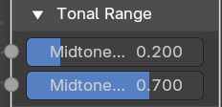
Tonal range panel

Mid tones Start, Mid tones End
Defines the start and the end of mid tones range, i.e. values where the whole tonal range is divided into the highlights, mid tones and shadows (there is also a smooth transition between the ranges of width 0.2 units).

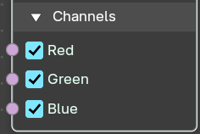
Channels

Red, Green, Blue
Specifies which RGB channels will be affected by correction.

Outputs

Color
The image output.

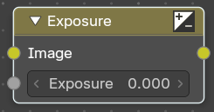
Exposure
The Exposure Node node allows you to make areas of an image brighter or dimmer.

Inputs

Image
Standard image input.

Exposure
The scalar factor to adjust the exposure of the image.

Outputs

Image
Standard image output.

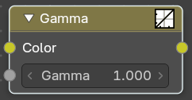
Gamma
Use this node to apply a gamma correction.

Inputs

Image
Image input.

Gamma
An exponential brightness factor.

Outputs

Image
Image output.

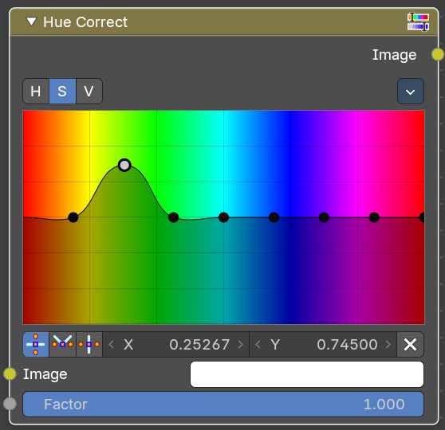
Hue Correct
With the Hue Correct Node you can adjust the Hue, Saturation, and Value of an image with an input curve.

Inputs

Image
Standard image input.

Factor
Controls the amount of influence the node exerts on the output image.

Properties

Level
H (Hue), S (Saturation), V (Value). Choose which curve you want to modify.

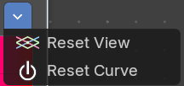
Tools menu

Reset View
Resets the view. This menu item is here dysfunctional, you cannot view in or out.

Reset Curve
Resets the curve to defaults.

Auto Handle
Sets the handle for the curve points to Auto Handle.

Vector Handle
Sets the handle for the curve points to Vector Handle.

Auto Clamped
Sets the handle for the curve points to Auto Clamped.

X / Y
The x and y position of the currently selected curve point.

Delete Points
Deletes the currently selected curve point.

Output

Image
Image Output

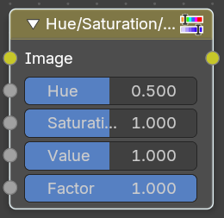
Hue/Saturation/Value
The Hue Saturation Node applies a color transformation in the HSV color space. Called “Hue Saturation Value” in shader and texture context.

Inputs / Properties
The inputs also works as properties when nothing is connected.

Image
Plug in an image.

Hue
Specifies the hue rotation of the image. 360° are mapped to (0 to 1). The hue shifts of 0 (-180°) and 1 (+180°) have the same result.

Saturation
A saturation of 0 removes hues from the image, resulting in a gray scale image. A shift greater than 1.0 increases saturation.

Value
Value is the overall brightness of the image. De/Increasing values shift an image darker/lighter.

Factor
Controls the amount of influence the node exerts on the output image.

Image
Standard input.

Outputs

Image
Standard output.

Hue/Saturation Tips
Some things to keep in mind that might help you use this node better:
Hues are vice versa
A blue image, with a Hue setting at either end of the spectrum (0 or 1), is output as yellow (recall that white, minus blue, equals yellow). A yellow image, with a Hue setting at 0 or 1, is blue.
Hue and Saturation work together.
So, a Hue of 0.5 keeps the blues the same shade of blue, but Saturation can deepen or lighten the intensity of that color.
Gray & White are neutral hues
A gray image, where the RGB values are equal, has no hue. Therefore, this node can only affect it with Value. This applies to all shades of gray, from black to white; wherever the values are equal.
Changing the effect over time
The Hue and Saturation values can be animated with a Time Node or by animating the property.

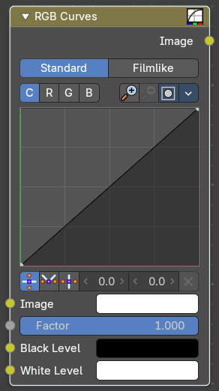
RGB Curves
The RGB Curves Node allows color corrections for each color channel and levels adjustments in the compositing context.

Inputs

Image
Standard image input.

Factor
Controls the amount of influence the node exerts on the output image.

Black Level
Defines the input color that is (linear) mapped to black.

White level
Defines the input color that is (linear) mapped to white.

Properties

Tone
What tone mapping to use. Standard or Film like.

Curve Field

Channel buttons
Clicking on one of the channels displays the curve for each.
C (Combined RGB), R (Red), G (Green), B (Blue).

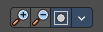
Navigation elements
They are described from left to right.

Zoom in and out
The two buttons with the magnifying glass at it zooms in and out in the curve window.

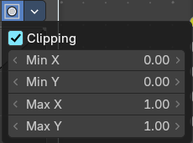
Clipping
Clipping options. Set up clipping for the stroke.

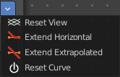
Tools
Tools is a menu where you can find some curve related tools.

Reset View
Resets the curve windows zoom.

Extend horizontal
Extends the curve before the first curve point and behind the last curve point horizontally.

Extend extrapolated
Extends the curve before the first curve point and behind the last curve point extrapolated.

Reset Curve
Resets the curve to the initial shape.

Curve edit field
Create and tweak a Bezier curve that varies the input levels (X axis) to produce an output level (Y axis).

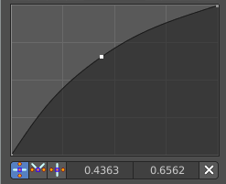
Selecting Points
You can select curve points. This reveals two edit boxes for the x and y coordinate of this point.
Selected points can be moved around. Left click at them, hold the mouse button down and move them to a new location.

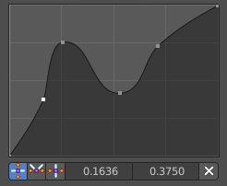
Adding Points
You can add new curve points by simply left clicking at the curve. Move the mouse to position them where you need it.

Curve point settings
When you have a point selected then you will reveal further settings at the bottom.

Vector Handle
Set handle type to Vector.

Auto Handle
Set handle type to Auto.

Auto Clamped Handle
Set handle type to Auto Clamped.

Outputs

Color
Standard output.

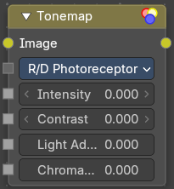
Tonemap
Tone mapping is a technique used in image processing and computer graphics to map one set of colors to another in order to approximate the appearance of high dynamic range images in a medium that has a more limited dynamic range.
Tone mapping addresses the problem of strong contrast reduction from the scene values (radiance) to the displayable range, while preserving the image details and color appearance. This is important to appreciate the original scene content.

Inputs

Image
Plug in the HDR image.

Properties

Type
There are two methods of tone mapping. Rh Simple and R/D Photo receptor.

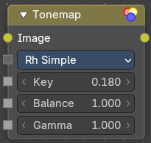
Rh Simple

Key
The value the average luminance is mapped to.

Balance
Normally always 1, but can be used as an extra control to alter the brightness curve.

Gamma
If not used, set to 1.

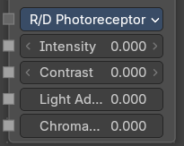
R/D Photo receptor

Intensity
A value smaller than zero darkens image. A value greater than zero makes it brighter.

Contrast
Set to 0 to use estimate from input image.

Adaptation
If 0, global; if 1, based on pixel intensity.

Color Correction
If 0, same for all channels; if 1, each independent.

Outputs

Image
The Image output.

